We invite all Legion members, active and auxiliary,
and our Spiritual Directors
to our
2026 Annual
Legion of Mary Acies Ceremony

here we will solemnly give ourselves
individually and collectively to
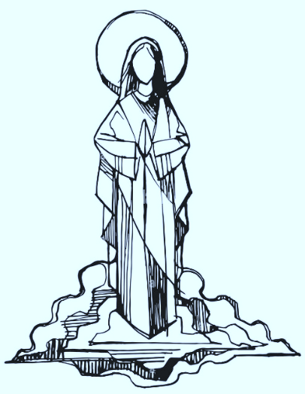
The Queen of the Legion & Queen of our Hearts!
Saturday, March 28th
Our Lady of Angels parish
13752 Mary’s Way, Woodbridge

schedule:
- 9am Mass (joined by others in the parish) in the main church.
- The Acies ceremony will begin after Mass, around 10am.
- A reception follows in the School Gymnasium, where food may be dropped off prior to the Mass. (Ends around 1 pm.)

active members should bring:
- Praesidium banners with stands & your Rosary.
- A ready-to-eat dish to share of your choice with a serving utensil.

leave banners & stands in the narthex as you arrive for Mass.

