The Legion of Mary
“Marian Apparitions: Messages for our time”

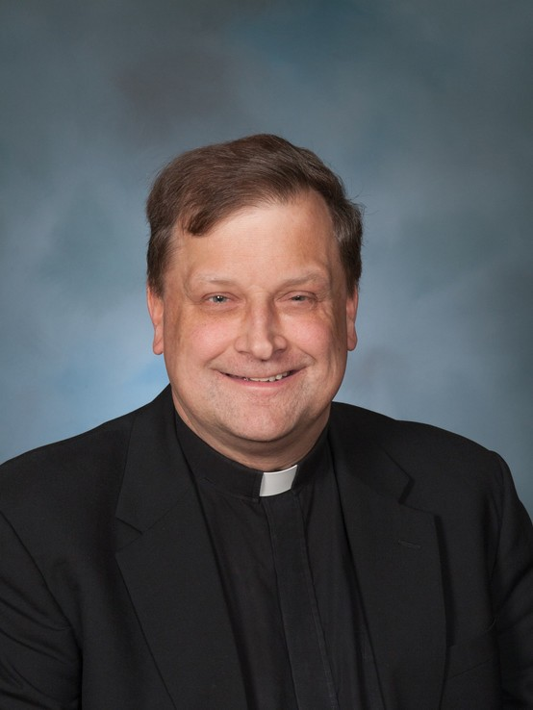
Loyola on the Potomac
9270Loyola Retreat Road
Faulkner, MD 20632

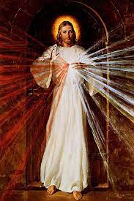

April 12, 13 & 14, 2024
The fee for overnight stay with all the meals for Friday-Sunday is $250.00 per person. Registration is limited to 59 people only, and social distancing is optional. First come, first served. Do not send registration to the retreat house.
The schedule of the retreat is attached.
Make payments before April 2, 2024 to the Legion of Mary and send to:
Edel Quinn House at 820 Gibbon St., Suite 201, Alexandria, VA 22314
For inquiries, please contact Vivian Moran (703) 888-8196
--------------------------------------------------------------------------------------------------------
Please fill out the form, cut along the line and send with your payment to Edel Quinn House only.

NAME_______________________________________________PHONE #_____________________

ADDRESS__________________________________________________________________________

Email___________________________________________PARISH___________________________

Please list any food allergies_____________________PRAESIDIUM_________________________

April 12, 13 & 14, 2024

FRIDAY 5:00 PM Arrival and check-in at door
5:45 PM Welcome, Orientation, and Announcements at the chapel
6:00 PM Angelus and Dinner, Silence cell phones at dining hall
7:00 PM Exposition of the Blessed Sacrament in Chapel (start of silence) Opening Prayers of Legion; Holy Rosary, Catena; Liturgy of the Hour (Evening Prayer) Benediction
8:00 PM Holy Mass (Homily-Conference #1)
9:00 PM Concluding Prayers of the Legion; Frank Duff Prayer;
Liturgy of the Hour (Night Prayer) Prayers)

SATURDAY 6:30 AM Coffee or tea for early risers
7:15 AM Opening Prayers of the Legion;
Holy Rosary (Spanish & Response in English; Liturgy of the Hour (Morning Prayer)
8:00 AM Angelus and Breakfast
9:00 AM Conference #2
10:00 AM Exposition and Private Meditations
11:00 AM Holy Mass (Homily-Conference #3) and Catena prayer
12:15 PM Angelus and Lunch
1:00 PM Quiet Private Time
2:00 PM Exposition of the Blessed Sacrament followed by confession (2:00-4:00PM) on ground floor
Eucharistic Adoration; Quiet time;
Confessions; Edel Quinn & Alfie Lambe Prayers
3:00 PM Chaplet of Divine Mercy
` 4:30 PM Conference #4
5:15 PM Liturgy of the Hour (Evening Prayer)
6:00 PM Angelus and Dinner
7:00 PM Conference #5
8:00 PM Concluding Prayers; Frank Duff Prayer,
Liturgy of the Hour (Night Prayer), All Night Adoration (please sign up)

SUNDAY 6:30 AM Coffee or tea for early risers
7:15 AM Opening Prayers of the Legion; Rosary, Liturgy of the Hour (Morning Prayer)
8.00 AM Angelus and Breakfast; Complete Retreat Evaluations
9:00 AM Silent Prayer
10:00 AM Conference #6; Catena
11:00 AM Holy Mass (Homily-Conference #7); Concluding prayers of the Legion, Frank Duff Prayer; silence lifted
12:00 PM Angelus, Group Pictures and Lunch
1:00 PM Socialization and Follow check out instructions;
2:00 PM Dismissal

