**The Arlington Regia Legion of Mary invites you to the**

**Eleventh Annual Clergy Appreciation**

**2023 Dinner and Talent Show**

**Sunday, September 17th. 2023**

**St. Veronica Parish**

**3460 Centreville Rd**, **Chantilly** **VA** **20151**

**6:00 – 8:00 PM**











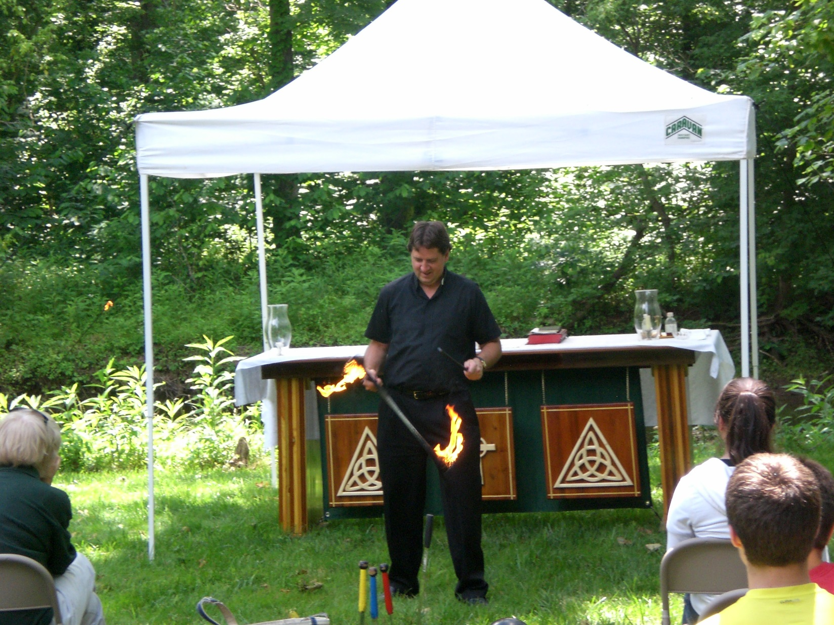



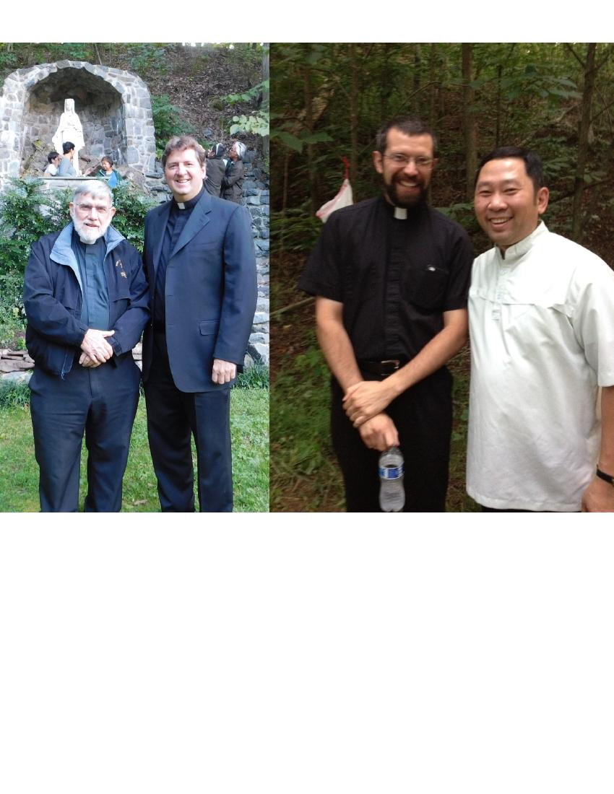

**Invite your priests & deacons and Legionaries prepare to entertain them!**







For more information and to **PLEASE RSVP** by September 1, 2023 call:

**Dr. Seggy Acosta (703) 392-6420, Virginia Pierson (703) 915-1318, Mary Bowes (703) 219-8888**

**Please give us your name, phone number, praesidium or council and how many people are coming.**



***Bring dishes that are ready to eat with***

***serving***

***utensils***

